SHRI SANJAY SAI SOUL BLOSSOMS (SSSSB), INTERNATIONAL
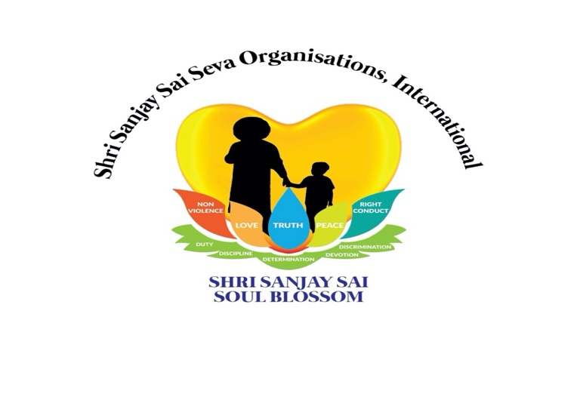
Registration form for Shri Sanjay Sai Soul Blossom Online Gurus Training
01 Date & Name: (full)
02 Name of Chapter or group you belong to:
03 Mobile number / Email ID:
04 Can you briefly tell us about yourself and why you want to become a Shri Sanjay Sai Soul Blossom Guru (SSSSB Guru)?
Notes:
You will receive a certificate after you have completed the course and complies with one of the two points:
Point 01: If you are not teaching classes as yet: After you have attended at least 10 Soul Blossom classes in total preferably in the same region that you are going to teach.
Point 02: If you are already teaching SSSSB classes:(how many classes have you taken)

Swami: A Message to the Teachers
"A teacher is just like a water tank. If the tank contains clean and pure water, very pure water comes out of the taps and the students are like the taps. They can be good if their teachers are good. The people who instruct them have a great influence on them, so they appear accordingly. If the teachers of high character teach them, the students possess the same sort of character. The teacher should be of high integrity. The teachers should first apply those things in their own lives what they are about to teach. They should have a sense of renunciation and surrender for their organization, so that such sense may spread among all students all over. To reform students, the teacher should reform himself first.
Human value is not a commodity to be sold in markets. It should reflect in character, not only in words. Such value shouldn't be taught only in the form of an academic discipline. Teachers should keep control over their own senses, and they must attain harmony in thoughts, words and deeds. When you find such harmony in you, you'll be an ideal teacher.”

NOTE: Send this form to your Chapter Chairman

